TEACHING STAFF
SL NO | Name | Designation | Educational Qualifications | Experience | Photo
1 | Dr.Mallikarjun B Kudavakkalagi | PRINCIPAL  (Regular) | M.A(Eng).  M.Sc(Psy).  M.Ed.,  UGC- NET, K-SET, Ph.D., | 16Yrs | 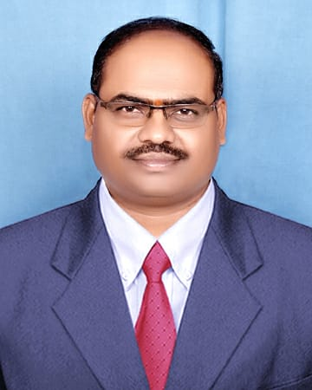
2 | Dr. VIJAYA SHIVAPUTRAPPA AGADI | ASSISTANT PROFESSOR  (Regular) | M.A,M.Ed, M.Phil.,Ph.D | 14Yrs | 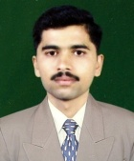
3 | Sri Kantharaj M S | ASSISTANT PROFESSOR  (Regular) | M.Sc,M.Ed, UGC-NET,K-SET | 12Yrs | 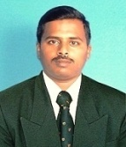
4 | Dr Basavaraj S | ASSISTANT PROFESSOR  (Regular) | M.Sc,M.Ed, K-SET.,Ph.D | 12Yrs | 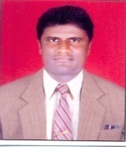
5 | Dr.S J Mahesha | ASSISTANT PROFESSOR | M.A,M.Ed, Ph.D | 06Yrs | 
6 | Dr Gururaj CS | ASSISTANT PROFESSOR | M.Sc.,M.Ed.,Ph.D. NET | 2Yrs | 
7 | Sri Praveena B M | Physical Director | M.P.Ed | 10Yrs | 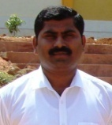
8 | Sri Kirankumar B | Lecturer | M.SC.,M.Ed | 02Yrs | 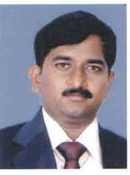
9 | Sri Rangaswamy R | Lecturer | M.A.(Fine Arts) | 02Yrs | 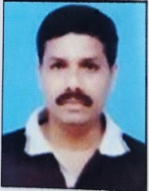
10 | Sri Vijayakumar NG | Librarian  (Regular) | M.Li.SC.,M.Phil | 16Yrs | 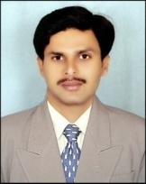
Non -- Teaching Staff
11 | Sri Shashidhar B R | F.D.A  (Regular) | M.SC. | 19Yrs | 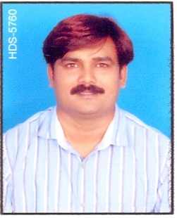
12 | Sri K.S.R.Prasad | S.D.A  (Regular) | B.A | 8Yrs | 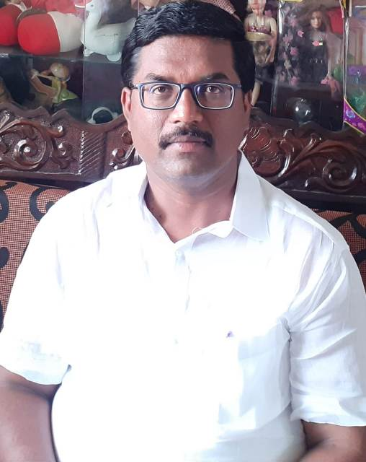
13 | Smt. D B Rekha | Peon  (Regular) | SSLC | 23Yrs | 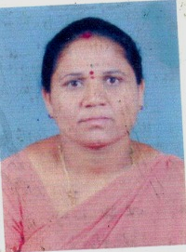
14 | Sri Thimmaiah | Attender | 7th Std | 02Yrs | 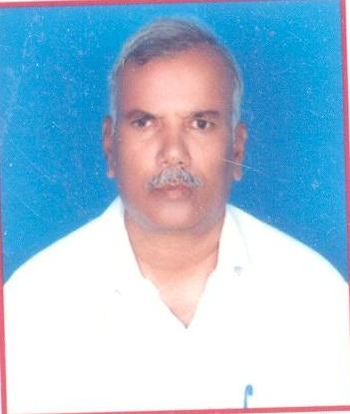

¸ÀzÀj «zÁåyðAiÀÄÄ UÀjµÀ× 1400 CAPÀUÀ½UÉ 1227 CAPÀUÀ¼À£ÀÄß ¥ÀqÉ¢zÀÄÝ, ±ÉÃPÀqÀªÁgÀÄ 87.64 ¥ÀqÉ¢gÀÄvÁÛgÉ.

